Visiativ Value Added Tutorial: How to add your Visiativ Solutions - SOLIDWORKS Dashboard.

In this tutorial we provide an overview of how you can access your Visiativ Solutions – SOLIDWORKS dashboard. This process is a Visiativ Value Added subscription benefit that will give you and your team easier and quicker access to SOLIDWORKS download media.

Not sure which license type you have or need a hand with your dashboard? Contact our support on support@visiativ.co.uk.

- Firstly you will need to accept your 3DEXPERIENCE licenses. These have been made available to you as part of your new subscription benefits.

You should have recived a CLOSA email, where you can accept the licenses. If you have not, we can easily provide this to you.

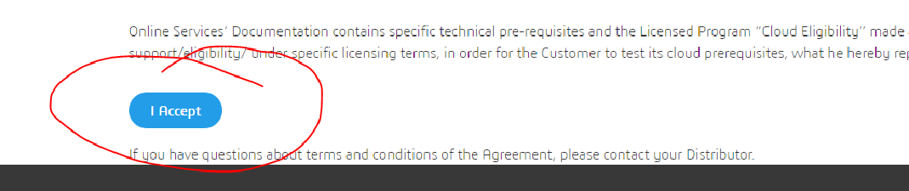

- Once the licenses have been accepted, you will receive another email. This will be sent to the same user that accepted the CLOSA agreement.

Within the email there is a link to ‘click here to become the first licensed user of your 3DEXPERIENCE Platform and the Administrator’. It is important that only the user that has been nominated to be the main Administrator clicks the link.

The person that clicks the link in the email will consume the first license and become the main Administrator. The role will be locked to that user for a minimum of 30 days.

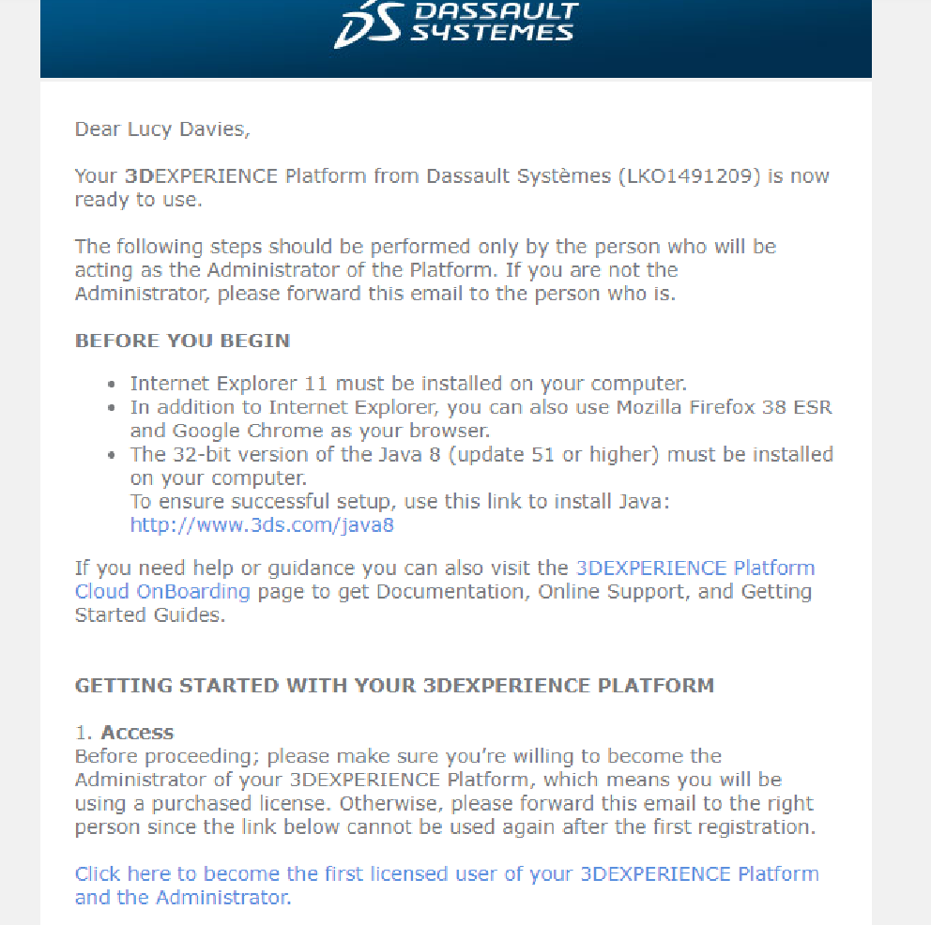

- After clicking the link, you will be directed to the 3DEXPERIENCE sign in page.

If you have a 3DEXPERENCE ID already (or have had a SOLIDWORKS Customer Portal account previously) use this to sign in.

If you do not have a 3DEXPERIENCE ID, hit Create. Create an account, then use that to log in.

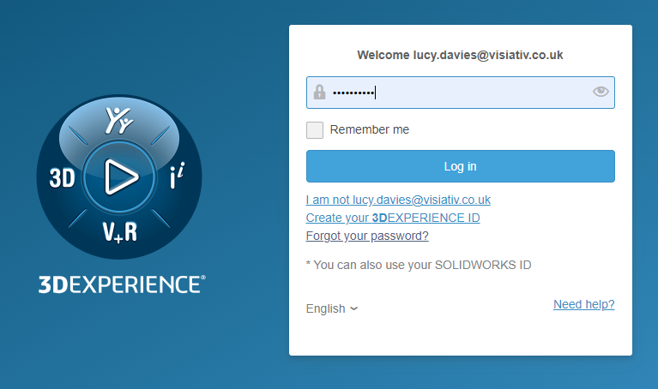

- Once you have logged in to your 3DEXPERIENCE tenant for the first time you should see a dashboard called My First Dashboard.

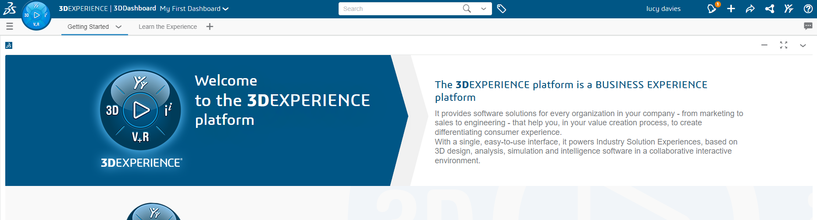

- When you have logged in for the first time, you will be able to access your provided Visiativ Solutions – SOLIDWORKS dashboard.

The link to your dashboard has been provided in your license detail email.

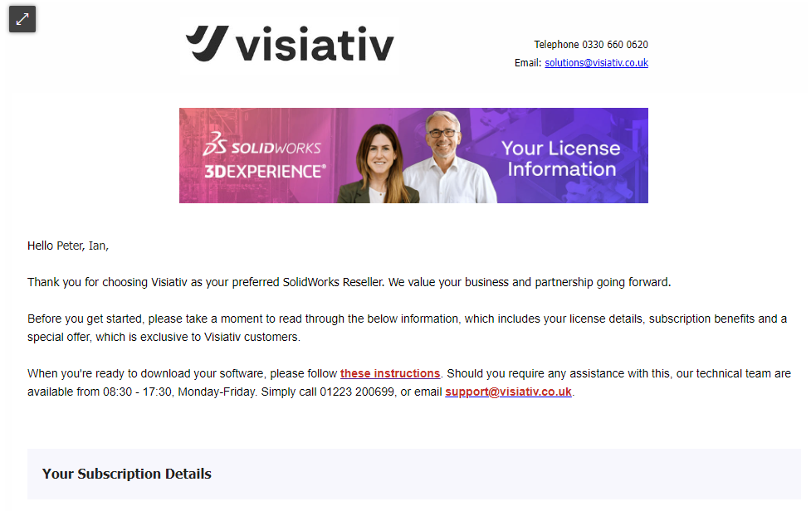

To access it, copy and paste the link in to your preferred browser.

- You should see a dialog box, like the one below, appear. Hit add.

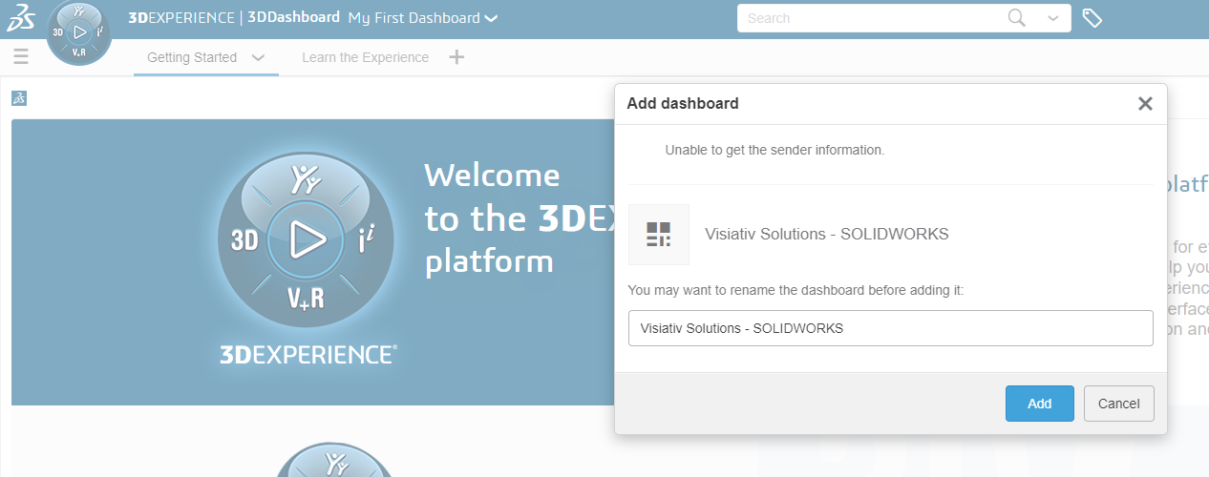

- The dashboard has now been added to your tenant.

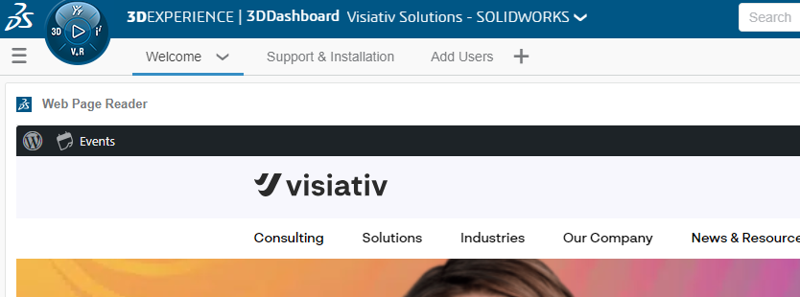

It is recommended that you bookmark this dashboard in your browser for easy access.

For information on how to add other users, share the dashboard with others and access the SOLIDWORKS download media. Visit the dashboard tabs.

