Visiativ Value Added Tutorial: How to share the dashboard with other users.

In this tutorial we provide an overview of how you can share your Visiativ Solutions – SOLIDWORKS dashboard with other users if you have multiple licneses. This process is a Visiativ Value Added subscription benefit that will give you and your team easier and quicker access to SOLIDWORKS download media. Note: to add another user to the system, you must have an availible IFW license.

Not sure which license type you have or need a hand with your dashboard? Contact our support on support@visiativ.co.uk.

Once you yourself have added the Visiativ Solutions – SOLIDWORKS dashboard to your 3DEXPERIENCE and added the other users to your tenant, you will be able to share the dashboard with them.

This will give them access to the easy SOLIDWORKS download media provided by Visiativ.

- With the dashboard active, hit Share.

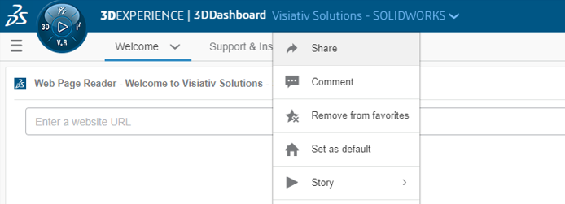

- Choose to ‘manage members’.

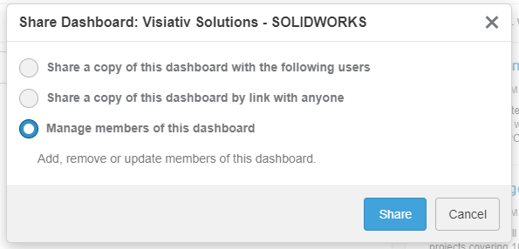

- Add members.



- Add the other users in your system by typing their usernames. Then hit add.

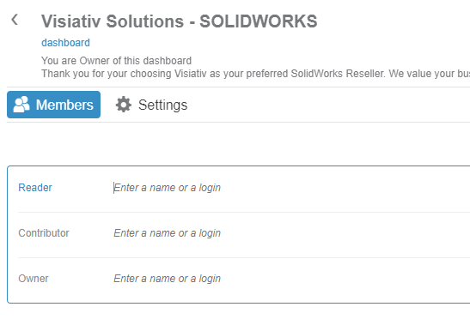

- Reader: can only view the dashboard content, not interact with it.
- Contributor: interact with the app and dashboard content but not edit the layout.
- Owner: can interact with the content and change the dashboard layout.

- The other users can then access the Visiativ Solutions – SOLIDWORKS from their dashboard list.

